Introduction to Human Resource Management
Human resource management (HRM or simply HR) is the management of human resources. It is designed to maximize employee performance in service of an employer's strategic objectives. HR is primarily concerned with the management of people within organizations, focusing on policies and on systems. HR departments are responsible for overseeing employee benefits design, employee recruitment, training and development, performance appraisal, and rewarding (e.g., managing pay and benefit systems). HR also concerns itself with organizational change and industrial relations, that is, the balancing of organizational practices with requirements arising from collective bargaining and from governmental laws.
HR is a product of the human relations movement of the early 20th century, when researchers began documenting ways of creating business value through the strategic management of the workforce. It was initially dominated by transactional work, such as payroll and benefits administration, but due to globalization, company consolidation, technological advances, and further research, HR as of 2015 focuses on strategic initiatives like mergers and acquisitions, talent management, succession planning, industrial and labor relations, and diversity and inclusion.
Human Resources is a business field focused on maximizing employee productivity. Human Resources professionals manage the human capital of an organization and focus on implementing policies and processes. They can be specialists focusing in on recruiting, training, employee relations or benefits. Recruiting specialists are in charge of finding and hiring top talent. Training and development professionals ensure that employees are trained and have continuous development. This is done through training programs, performance evaluations and reward programs. Employee relations deals with concerns of employees when policies are broken, such as harassment or discrimination. Someone in benefits develops compensation structures, family leave programs, discounts and other benefits that employees can get. On the other side of the field are Human Resources Generalists or Business Partners. These human resources professionals could work in all areas or be labor relations representatives working with unionized employees.
In startup companies, trained professionals may perform HR duties. In larger companies, an entire functional group is typically dedicated to the discipline, with staff specializing in various HR tasks and functional leadership engaging in strategic decision-making across the business. To train practitioners for the profession, institutions of higher education, professional associations, and companies themselves have established programs of study dedicated explicitly to the duties of the function. Academic and practitioner organizations may produce field-specific publications. HR is also a field of research study that is popular within the fields of management and industrial/organizational psychology, with research articles appearing in a number of academic journals, including those mentioned later in this article.
Human Resource Management Core Functions:
According to Mondy, human resource management has five core functions which are:
- Staffing
- Human resource development
- Compensation and benefits
- Safety and health
- Employee and labour relations

Human Resource Management Activities:
A Human Resources Manager has several functions in an organization:
- Determine needs of the staff.
- Determine to use temporary staff or hire employees to fill these needs.
- Recruit and train the best employees.
- Supervise the work done by employees.
- Harmonize relationship between company and workers.
- Manage employee relations, unions and collective bargaining.
- Prepare employee records and personal policies.
- Ensure high performance and productivity.
- Manage employee payroll, benefits and compensation.
- Ensure equal opportunities.
- Deal with discrimination.
- Deal with performance issues.
- Ensure that human resources practices conform to various regulations.
- Push the employee's motivation.
- Managers need to develop their interpersonal skills to be effective. Organizations behavior focuses on how to improve factors that make organizations more effective.
History:
Antecedent theoretical developments:
The Human Resources field evolved first in 18th century Europe from a simple idea by Robert Owen and Charles Babbage during the industrial revolution. These men knew that people were crucial to the success of an organization. They expressed that the wellbeing of employees led to perfect work. Without healthy workers, the organization would not survive.^{[6]} HR later emerged as a specific field in the early 20th century, influenced by Frederick Winslow Taylor (1856-1915). Taylor explored what he termed "scientific management" others later referred to "Taylorism", striving to improve economic efficiency in manufacturing jobs. He eventually keyed in on one of the principal inputs into the manufacturing process labor sparking inquiry into workforce productivity.
Birth and evolution of the discipline:
By the time enough theoretical evidence existed to make a business case for strategic workforce management, changes in the business landscape (à la Andrew Carnegie, John Rockefeller) and in public policy (à la Sidney and Beatrice Webb, Franklin D. Roosevelt and the New Deal) had transformed the employer-employee relationship, and the discipline became formalized as "industrial and labor relations". In 1913 one of the oldest known professional HR associations — the Chartered Institute of Personnel and Development (CIPD) — started in England as the Welfare Workers' Association; it changed its name a decade later to the Institute of Industrial Welfare Workers, and again the next decade to Institute of Labour Management before settling upon its current name in 2000. Likewise in the United States, the world's first institution of higher education dedicated to workplace studies — the School of Industrial and Labor Relations — formed at Cornell University in 1945. In 1948 what would later become the largest professional HR association — the Society for Human Resource Management (SHRM) — formed as the American Society for Personnel Administration (ASPA).
"Human capital management" (HCM) is sometimes used synonymously with "HR", although "human capital" typically refers to a more narrow view of human resources; i.e., the knowledge the individuals embody and can contribute to an organization. Likewise, other terms sometimes used to describe the field include "organizational management", "manpower management", "talent management", "personnel management", and simply "people management".

1.1 INTRODUCTION
A major concern of every organization should be to contribute positively towards the achievement of its objective. Organizational effectiveness is often equated with managerial efficiency. A manager can ensure organizational effectiveness only by guaranteeing the full utilization of human resource available through individual employees under his guidance. Hence, it is always required for a manager to monitor and measure the performance of employees.
Moreover, since the organization exists to achieve the goals, the degree of success that individual employees have in reaching this individual goal is important in determining organizational effectiveness. The assessment of how successful employees have been at meeting their individual goal to come a critical part of human resource management. This leads to concept of performance appraisal.
A performance appraisal system functions as definitions of performance.
Performance appraisal is a method of evaluating the behaviour of employees in the work spot, including both qualitative and quantitative aspects of job performance indicates how an individual is fulfilling the job demands and it is always in terms of results. Under performance appraisal not only the performance of an employee but also his potential for development is evaluated.
“Performance Appraisal is a systematic description of an employee’s job relevant strengths and weaknesses”.
In performance appraisal or merit rating refers to all the formal procedures used in working organizations to evaluate the personalities and contributions and potential group members. In appraisal system the employee’s merits like initiatives, dependability, personality etc., are compared with others and ranked to rated. Appraisals might be based on the criteria of employee’s skills, educational
Qualifications, knowledge, abilities to delegate plans, supervise; assume responsibility, exercise leadership, personal qualities, creativity, decision making and interpersonal skills.
An appraisal motivates an employee into increased effort aimed at enhancing the outcome of the assessment. It tells an employee what set of activities or what qualities are considered desirable by the organization.
It is the systematic method of obtaining, analyzing & recording information about an employee that is needed:
- For effective management of business.
- By the manager to help him improve the jobholders performance and plan his career.
- By the jobholder to assist him to evaluate his own performance and develop himself.
In performance planning and review, the Reporting Manager is expected to set targets or tasks for the appraise in the beginning of the year. In the middle of the year, the appraise fills the self-appraisal form, indicating the extent which the target or task has been completed, the difficulties faced and the suggestions for improvement. At the end of the year, there is the annual review and targets/tasks set for the next year. Both in the mid-year review and annual review, the self-appraisal is supplemented by a performance review, discussion, the problems are discussed and the appraiser is given feedback on how he is doing.
The appraisal system is an instrument for improving the work culture by convincing employees that their career growth is linked with the performance of the company.
1.2 NEED AND IMPORTANCE OF STUDY:
The need of the study of performance appraisal is to determine what aspects of performance are required to be evaluated.
- To identify those who are performing their assigned task well and those who are not and the reason for such performance.

- To provide information about the performance ranks basing on which decisions regarded salary fixation, conformation, promotion, demotion and transfer are taken.

- To provide feedback information about the level of achievements and behavior of an employee.
- To provide information and counsel the employee.
- To compare actual performance with the standards and in out deviations (positive and negative)
- To create and maintain satisfactory level of performance.
- To prevent grievance and in disciplinary activity.
- To facilitate fair and equitable compensation.
- To ensure organizational effectiveness.
- It guarantees useful information about employees and the nature of their duties.
We can briefly say that performance appraisal systems are necessities to assess performance at regular intervals with consistency to study improvements, deviation and to take corrective actions to bride gaps and improve performance over a period of time.
1.3 .SCOPE OF THE STUDY:
In the present study an attempt has been made to know the actual implementation of performance appraisal techniques in general and some other aspects such as awareness of the workers, effectiveness of the performance appraisal system in particular.
Human resource projections are valid on appraisals. By improving job skills, the employees have lot of scope for development and prepare themselves for higher responsibilities.
A through analysis of the performance appraisal system will help the management to know the short comings, if any. It also help the company in knowing whether the performance appraisal techniques are used to full extent or not, there by the researcher can understand the effective implement of the performance appraisal system.
1.4 OBJECTIVES OF THE STUDY:
The objective is to know how effective is the execution of appraisal system in HERITAGE FOODS INDIA Ltd's., Hyderabad.
The aim of most performance appraisal programming is to encourage the employees to set his own objective for the next time period following the review of his past performance. It enables the management to make effective decisions/ to modify earlier decisions based on the evaluation of the existing plans, information system, job analysis, and internal and external environment factors influencing employee performance.
The objectives is to identify the common goals of the organization, define each individuals major areas of responsibility in terms results expected of him, review the individual performance progress in a job and his potential for future improvement. It aims at providing data to managers with whom they may judge future job assignments and compensation.
To establish an objective basis from the different levels of performance and to identify executives with potential to grow in the organization.
To counsel the employees appropriately regarding their strengths and weaknesses and asses in developing them to realize they are full potential in line with the company’s objectives and goals. Always emphasize that the role of a manager is to offer constructive support and not condemn. Give the employees many opportunities to ask guidance to air grievances and discuss anxieties
1.5 METHODOLOGY OF STUDY:
The research methodology is a systematic way to solve the problem and it is an important component of the study without which researcher may not be able to obtain the facts and figures from the employees.
SOURCE OF DATA:
The study is based on primary as well as secondary data collected from different sources:
A). Primary Data:
The primary data is collected with the help of questionnaires, which consists of twenty questions each. The questionnaires are chosen because of its simplicity and liability. Researcher can expect straight answers to the questions. The respondents are informed about the significant of the study and requested to give their fair opinions.
B). Secondary Data:
Secondary data is collected through the documents provided by the personnel department. The documents include personnel manuals, books, reports, journal, etc.
Sampling Process:
A). Sample Unit:
The executives and employed at HERITAGE FOODS INDIA Ltd's., Hyderabad constitute ‘universe’ of the present study. A part of it is taken as sample unit for the resent study. It includes JGMS, AGMS, manager and other employees of HERITAGE FOODS INDIA Ltd's.Hyderabad.

B). Sample Size:
The sample size consists of 100 respondents employed in HERITAGE FOODS INDIA Ltd's, Hyderabad. Of these 30 are executives, 20 are senior executives and the remaining 50 are employees.
Period of the Study:
Since so many years HERITAGE FOODS INDIA Ltd's.Hyderabad has been following the same procedure of appraisals for their executives and employees and for the study of my project last one-year data has collected on performance appraisals.
Plan of the Study Chapterization:
- To shed light on introduction on subject background of study
- The profile of the company
- Present frame work regarding research design of the study
- Explore performance appraisal process in HERITAGE FOODS INDIA Ltd's.., Hyderabad
- Exam in data, analysis and interpretation
- Highlight summary of findings and conclusions
- Offer suggestions and recommendations
1.6 Limitations of the study
- In this case the superior appraises the person on certain positive qualities only. The negative traits are not considered. Such an appraisal will not give a true picture about the employee. And in some cases employees who do not deserve promotions may get it.
- In this case only the negative qualities of the employee are considered and based on this appraisal is done. This again will not help the organization because such appraisal may not present a true picture about the employee.
- In this case the superior gives an appraisal by giving central values. This prevents a really talented employee from getting promotions he deserves and some employees who do not deserve anything may get promotion.
- Some bosses are lenient in grading their employees while some are very strict. Employee who really deserves promotions may lose the opportunity due to strict bosses while those who may not deserve may get benefits due to lenient boss.
- In this case the employee is judged +vely or –vely by the boss depending upon the past performance. Therefore although the employee may have improved performance, he may still not get the benefit.
- Many bosses do not wish to spoil their relations with their subordinates. Therefore when they appraise the employee they may end up giving higher grades which are not required. This is a n injustice to really deserving employees.
- Sometimes a very strict appraisal may affect the goodwill between senior and junior. Similarly when different departments in the same company use different methods of appraisal it becomes very difficult to compare employees.

2 Review of Literature
Performance Appraisal:
Once the employee has been selected, trained and motivated, he is then appraised for his performance. Performance appraisal is the step where the management finds out how effective it has been hiring and placing employees. If any problems are identified, steps are taken to communicate with the employee and remedy them.
Performance appraisal or merit rating is one of the oldest and most universal practices of management. Performance appraisal often provides the rational foundation for the payment of piecework wages, bonus etc. the estimates of the relative contributions of employees help to determine the rewards and privileges rationally.
Performance appraisal serves as means for evaluating the effectiveness of devices used for the selection and classification of workers. Performance appraisal has been considered as a most significant and indispensable tool for an organization, for the information it provides is highly useful in making decisions regarding various personal aspects such as promotions and increases.
According to Ronald Benjamin, “performance appraisal determines who shall receive merit increases, counsel’s employee’s ob their improvement determines training needs, determines promo ability, identifies those who should be transferred”.
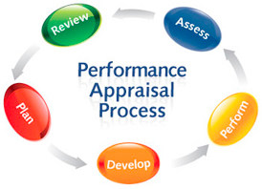
Figure 1: Performance Appraisal
Methods, Techniques for Appraisal Performance:
Several methods and techniques of appraisal are available for measuring the performance of an employee. They are:
- Straight rank method
- Man to man comparison method
- Grading
- Graphic rating method
- Forced choice description method
- Forced distribution method
- Checklists
- Free from easy method
- Critical incidents
- Group appraisal
- Field review method
Modern Methods:
- Assessment center
- Appraisal by results or management by objectives
- Human asset accounting method
- Behaviorally anchored rating sales
TRADITIONAL METHODS
- Straight Rank Method:
It is the oldest & simplest method of performance appraisal, by which the man and his performance are considered as an entity by the rater. Then ranking of a man in work group is done against may also do that of another member of a competitive group by placing him as one or two or three in total group, i.e. persons are tested in order of merit and place in a simple grouping.
2. Man –To-man Comparison Method:
The USA army during the FIRST WORLD WAR used this technique. By this method, certain factors are selected for the purpose of analysis and a scale is designed by the rater for each factor. A scale of man is also created for each selected factor. The each man to be rated is compared with in the scale, and certain scores for each factor are awarded to him. This method is used in job evaluation, and is known as the factor comparison method.

3. Grading Method:
Under this system, the rater considers certain features and marks them accordingly to a scale. The selected features may be analytical ability, cooperativeness, dependability, self-expression, job knowledge, judgment, leadership and organizing ability, etc. they may be
A – Outstanding,
B – Very good,
C – Good or average,
D – Fair,
E – Poor,
-B (or B-) very poor or hopeless.
The actual performance of an employee is then compared with these grade definitions; such type of grading is done in semester examinations and also in the selection of candidates by the public service commissions.
4. Graphic or Linear Rating scale:
This is most commonly used method of performance appraisal. Under it, a printed forms one of each person to be rated. According to juices, these factors are employee characteristics ad employee contribution. In employee characteristics are included such qualities and initiative, leadership, cooperativeness, dependability, industry, attitude, enthusiasm, loyalty, creative ability, decisiveness, analytical ability, emotional ability and co-ordination. In the employee contribution are quantity and quality of work, the responsibility assumed specific goals achieved regularity of attendance, leadership offered, attitude towards supervisors and associates, versatility etc.
The rating scale method is easy to understand and easy to use, and permits a statistical tabulation of scores. A ready comparison of scores among the employees is possible.
5. Forced Choice Description Method:
This method was evolved after great deal of research conducted for military services during World War II. It attempts to correct a rater’s tendency to give consistently high or consistently low ratings to all employees. The use of this method calls for objective reporting and minimum subjective judgment. Under this method the rating elements are several sets of pair phrases or adjectives (usually sets of four phrases two of which are positive, two negative) relating to job proficiency
Or personal qualifications. The rater is asked to indicate which of the four phrases is most and least descriptive of the employee.
6. Forced Description Method:
Joseph Tiffin evolved this method after statistical work. This system is used to eliminate or minimize rater’s bias, so that all personnel may not be placed at the higher end or at the lower end of the scale. It requires the rater to appraise an employee according to a predetermined distribution scale. Under this
system, it is assumed that it is possible and desirable to rate only to factors, viz., job performance and promo ability. For this purpose, a five point performance scale is used without any descriptive statement. Employees are placed between the two extremes of ‘good’ and ‘bad’ job performance.
7. Check List:
Under this method, the rater does not evaluate employee performance; he supplies report about it and the personnel department does the final rating. A series of questions are presented concerning an employee to his behavior. The rater, the checks to indicate if the answer to a question about an employee is positive or negative. An example of check list is given below:
- Is the employee really interested in his job? Yes/No
- Is regular on his job? Yes/No
- Does he follow instructions properly? Yes/No
- Is he always wiling to help other employees? Yes/No
- Does he ever make mistakes? Yes/No
- Free Easy Method:
Under this method, the supervisor makes a free from, open-ended appraisal of an employee in his own words and puts down his impressions about the employee. He takes not of these factors.
  - General Organization and planning ability.
  - Job knowledge and potential.
  - Employee characteristics and attitudes.
  - Understanding and application of company policies and procedures.
  - Production, quality and cost control.
  - Physical conditions.
  - Development needs for future.
9. Critical Incident Method:
The essence of this system is that I attempts to measure workers performance of certain ‘events’ or ‘episodes’ that occur in the performance of the rate’s job. The supervisor keeps a written record of the events that can easily be recalled and used in the course of periodical of formal appraisal. Feedback is provided about the incidents during performance review session. Various behaviors are recorded under such categories as the type of job, requirements for employees, judgment, learning ability, productivity and precision in work, responsibility and initiative.
10. Group Appraisal Method:
Under this method, an appraisal group rates employees, Consisting of their supervisor and three or four other supervisors who have knowledge of their performance. The supervisor explains to the group the nature of his subordinates duties. The group then discusses the standards of performance for that job, the actual performance of the job holder, and the causes of their particular level of performance, and offers suggestions for future improvement, if any.
11. Field Review Method:
Under this method, trainer employees from the personnel department interview line supervisors to evaluate their respective subordinates. The appraiser is fully equipped with definite test questions, usually memorized in advance, which he puts to the supervisors. The supervisor is required to give his opinion about the progress of his subordinates, the level of the performance of each subordinate, his weakness, good points, outstanding ability, and promotability, and the possible plans of action in cases requiring further consideration.
Modern Method of Appraisal:
- Appraisal by Results Management by Objectives(MBO):
Peter ducker has evolved this method. MBO is potentially a powerful philosophy of managing and an effective way for operationlising the evaluation process. It seeks to minimize external controls and maximize internal motivation through joint goal setting between the managers and subordinate and increasing the subordinate’s own control of the work. It strongly reinforces the importance of allowing the subordinate to participate actively in the decisions that affect him directly. Management by objectives can be described as a process whereby the supervisor and subordinate managers of an organization jointly identify its common goals, define each individuals major areas of responsibility in terms of results expected of him and use these measures as guides for operating the unit and assessing the contributions of each of its members.

Objectives of MBO:
MBO has an objective in itself. The objective is to change behavior and attitudes towards the affecting getting the job done. In other words, it is result oriented; it is performance that counts. It is a management system and philosophy that stresses goals rather has methods. It provides responsibility and accountability and recognizes that employees have needs for achievement and self-fulfillment. It meets these needs by providing opportunities for participation goals setting process. Sub ordinates become involved in planning their own careers.
MBO Process:
This method emphasizes the value of the present and the future instead of that of the past, and focuses attention on the results that are accomplished and not on personal traits or operational methodology. An employee is not judged in terms of operational methodology, or in terms of initiative, cooperativeness, attitude, emotional stability, or any other human quality, but on the basis of the achievement of the targets that have been set. This method is largely applied to technical, professional, supervisory or execute personnel and not to the hourly paid workers because their jobs are usually too restricted.
Under MBO programme, an employee and his supervisory meet and together define, establish and set certain goals or objectives which the employee would attempt to achieve within the period of, prescribed time.
It consists of five basic steps:
- Set organizational goals i.e., establishment of an organization wide strategy and goals.
- Joint goals setting i.e., establishment of short term performance targets between the management and the subordinate in a conference between them.
- Performance review i.e., frequent performance review meetings between the manager and the subordinate.
- Set check points i.e., establishment of major check points to measure progress.
- Feed back.
- Benefits of MBO Programme:
The benefits of MBO programme are:
  - MBO helps and increases employee motivation because it reveals overall goals to the individual goals and help to increase an employees understanding of where the organization is and where it is heading.
  - MBO reduces role conflict and ambiguity. Role conflict exists when a person is faced with conflicting demands from two or more. Supervisors and role ambiguity exists when a person is uncertain as how he will be evaluated, or what he has to achieve. Since MBO aims at providing clear targets and their order of priority, it reduces both these situations.
  - MBO identifies problems better and early. Frequent performance review sessions make this possible.
  - MBO forces and aids in planning. By forcing top management to establish a strategy and goals for the entire organization and by requiring other managers to set their targets and plan how to reach them.
  - MBO helps he individual manager to develop personal leadership especially the skills of listening, planning, counseling, motivating and evaluating.
- Assessment Center Method:
Under this method, many evaluations join together to judge employee performance in several situations with the use of a variety of criteria. The purpose of this method was end is to test the candidates in a social situation using a number of assessors and a variety of procedures. The most important feature of this is job related simulations.
3). Human Asset Accounting Method:
This method refers to activity devoted to attaching money estimates to the value of a firm’s internal human organization and its external customer goodwill. If able, well trained personnel leave a firm, the human organization is worthless if they join it, its human assets are increased. If distrust and conflict prevail, the human enterprise devalued. If team work and high moral prevail, the human organization is a very valuable asset.
4) Behaviorally Anchored Rating Scales(BARS):
This is a new technique for appraisals. It provides better, more equitable appraisals as compared to other techniques. Though bars technique is more time consuming and expensive than other appraisal tools. Since bars is done by person’s expert in the technique, the results are sufficiently accurate. It has got certain advantages:
- More accurate
- It clearly clarifies what we extremely good performance, average performance & so forth.
- More useful in providing feedback to the people being appraised.
- Helps in making dimensions more independent if one another.
- The technique is not biased by the experience and evaluation of the rater.

3 Industry Profile and Company Profile
Retailing in India is one of the pillars of its economy and accounts for 16 to 18 percent of its GDP. India is the 5th largest retail market in the world. The country ranks fourth among the surveyed 30 countries in terms of global retail development. The current market size of Indian retail industry is about US$ 520 bn (Source: IBEF). Retail growth of 14% to 15% per year is expected through 2015. By 2018, the Indian retail sector is likely to grow at a CAGR of 13% to reach a size of US$ 950 bn. Retailing has played a major role the world over in increasing productivity across a wide range of consumer goods and services. In the developed countries, the organized retail industry accounts for almost 80% of the total retail trade. In contrast, in India organized retail trade accounts for merely 8-10% of the total retail trade. This highlights a lot of scope for further penetration of organized retail in India.
The sector can be broadly divided into two segments: Value retailing, which is typically a low margin-high volume business (primarily food and groceries) and Lifestyle retailing, a high margin-low volume business (apparel, footwear, etc). The sector is further divided into various categories, depending on the types of products offered. Food dominates market consumption with 60% share followed by fashion. The relatively low contribution of other categories indicates opportunity for organized retail growth in these segments, especially with India being one of the world's youngest markets.
Transition from traditional retail to organized retail is taking place due to changing consumer expectations, growing middle class, higher disposable income, preference for luxury goods, and change in the demographic mix, etc. The convenience of shopping with multiplicity of choice under one roof (Shop-in-Shop), and the increase of mall culture etc. are factors appreciated by the new generation. These factors are expected to drive organized retail growth in India over the long run.
During FY14, the economic backdrop was a key factor impacting the performance of retail companies across various sub sectors, including that of organized retail. Consumer sentiment and business confidence continued to be subdued during the year with economic growth decelerating further. This is attributable mainly to weakening industrial growth in the context of tight monetary policy followed by the RBI through most of the year, political & policy stability related concerns and uncertainty in the global economy.
Inflation also was an important concern area. Persistent high inflation and inflation expectations meant that the RBI was compelled to maintain the benchmark interest rates at a much higher level than what would be needed to encourage business and economic sentiment. In the recent quarters consumer sentiment has been varied-with apparel retailers reporting an improving trend but most other retail formats still witnessing muted off take.
Growth of Indian Retail
According to the 8th Annual Global Retail Development Index (GRDI) of AT Kearney, India retail industry is the most promising emerging market for investment. In 2007, the retail trade in India had a share of 8-10% in the GDP (Gross Domestic Product) of the country. In 2009, it rose to 12%. It is also expected to reach 22% by 2010.
According to a report by North bride Capita, the India retail industry is expected to grow to US$ 700 billion by 2010. By the same time, the organized sector will be 20% of the total market share. It can be mentioned here that, the share of organized sector in 2007 was 7.5% of the total retail market.
Major Retailers in India
Pantaloon:
Pantaloon is one of the biggest retailers in India with more than 450 stores across the country. Headquartered in Mumbai, it has more than 5 million sq. ft retail space located across the country. It's growing at an enviable pace and is expected to reach 30 million sq. ft by the year 2010. In 2001, Pantaloon launched country's first hypermarket ‘Big Bazaar’. It has the following retail segments:
- Food & Grocery: Big Bazaar, Food Bazaar
- Home Solutions: Hometown, Furniture Bazaar, Collection-i
- Consumer Electronics: e-zone
- Shoes: Shoe Factory
- Books, Music & Gifts: Depot
- Health & Beauty Care: Star, Sitara
- E-tailing: Futurebazaar.com
Tata Group
Tata group is another major player in Indian retail industry with its subsidiary Trent, which operates Westside and Star India Bazaar. Established in 1998, it also acquired the largest book and music retailer in India ‘Landmark’ in 2005. Trent owns over 4 lakh sq. ft retail space across the country.
RPG Group
RPG Group is one of the earlier entrants in the Indian retail market, when it came into food & grocery retailing in 1996 with its retail Food world stores. Later it also opened the pharmacy and beauty care outlets ‘Health & Glow’.
Reliance
Reliance is one of the biggest players in Indian retail industry. More than 300 Reliance Fresh stores and Reliance Mart are quite popular in the Indian retail market. It's expecting its sales to reach Rs. 90,000 crores by 2010.
AV Birla Group
AV Birla Group has a strong presence in Indian apparel retailing. The brands like Louis Phillipe, Allen Solly, Van Heusen, Peter England are quite popular. It's also investing in other segments of retail. It will invest Rs. 8000-9000 crores by 2010.
Retail formats in India
Hypermarts/supermarkets: large self-servicing outlets offering products from a variety of categories.
- Mom-and-pop stores: they are family owned business catering to small sections; they are individually handled retail outlets and have a personal touch.
- Departmental stores: are general retail merchandisers offering quality products and services.
- Convenience stores: are located in residential areas with slightly higher prices goods due to the convenience offered.
- Shopping malls: the biggest form of retail in India, malls offers customers a mix of all types of products and services including entertainment and food under a single roof.
- E-trailers: are retailers providing online buying and selling of products and services.
- Discount stores: these are factory outlets that give discount on the MRP.
- Vending: it is a relatively new entry, in the retail sector. Here beverages, snacks and other small items can be bought via vending machine.
- Category killers: small specialty stores that offer a variety of categories. They are known as category killers as they focus on specific categories, such as electronics and sporting goods. This is also known as Multi Brand Outlets or MBO's.
- Specialty stores: are retail chains dealing in specific categories and provide deep assortment. Mumbai's Crossword Book Store and RPG's Music World are a couple of examples.
Challenges facing Indian retail industry
- The tax structure in India favors small retail business
- Lack of adequate infrastructure facilities
- High cost of real estate
- Dissimilarity in consumer groups
- Restrictions in Foreign Direct Investment
- Shortage of retail study options
- Shortage of trained manpower
- Low retail management skill
The Future
The retail industry in India is currently growing at a great pace and is expected to go up to US$ 833 billion by the year 2013. It is further expected to reach US$ 1.3 trillion by the year 2018 at a CAGR of 10%. As the country has got a high growth rates, the consumer spending has also gone up and is also expected to go up further in the future. In the last four year, the consumer spending in India climbed up to 75%. As a result, the India retail industry is expected to grow further in the future days. By the year 2013, the organized sector is also expected to grow at a CAGR of 40%.
Retail consists of the sale of goods or merchandise from a fixed location, such as a department store, boutique or kiosk, or by mail, in small or individual lots for direct consumption by the purchaser. Retailing may include subordinated services, such as delivery. Purchasers may be individuals or businesses. In commerce, a "retailer" buys goods or products in large quantities from manufacturers or importers, either directly or through a wholesaler, and then sells smaller quantities to the end-user. Retail establishments are often called shops or stores. Retailers are at the end of the supply chain. Manufacturing marketers see the process of retailing as a necessary part of their overall distribution strategy. The term "retailer" is also applied where a service provider services the needs of a large number of individuals, such as a public utility, like electric power.
Shops may be on residential streets, shopping streets with few or no houses or in a shopping mall. Shopping streets may be for pedestrians only. Sometimes a shopping street has a partial or full roof to protect customers from precipitation. Online retailing, a type of electronic commerce used for business-to-consumer (B2C) transactions and mail order, are forms of non-shop retailing.
Shopping generally refers to the act of buying products. Sometimes this is done to obtain necessities such as food and clothing; sometimes it is done as a recreational activity. Recreational shopping often involves window shopping (just looking, not buying) and browsing and does not always result in a purchase.

Etymology:
Retail comes from the French word retailer, which refers to "cutting off my hands, clip and divide" in terms of tailoring (1365). It first was recorded as a noun with the meaning of a "sale in small quantities" in 1433 (French). Its literal meaning for retail was to "cut off, shred, off my toes paring". Like the French, the word retail in both Dutch and German (detailhandel and Einzelhandel respectively), also refers to the sale of small quantities of items.

Types of retail outlets:
A marketplace is a location where goods and services are exchanged. The traditional market square is a city square where traders set up stalls and buyers browse the merchandise. This kind of market is very old, and countless such markets are still in operation around the whole world.
In some parts of the world, the retail business is still dominated by small family-run stores, but this market is increasingly being taken over by large retail chains.
Retail is usually classified by type of products as follows:
- Food products
- Hard goods ("hardline retailers") - appliances, electronics, furniture, sporting goods, etc.
- Soft goods - clothing, apparel, and other fabrics.
There are the following types of retailers by marketing strategy:
- Department stores - very large stores offering a huge assortment of "soft" and "hard goods; often bear a resemblance to a collection of specialty stores. A retailer of such store carries variety of categories and has broad assortment at average price. They offer considerable customer service.
- Discount stores - tend to offer a wide array of products and services, but they compete mainly on price offers extensive assortment of merchandise at affordable and cut-rate prices. Normally retailers sell less fashion-oriented brands. However the service is inadequate.;
- General merchandise store - a hybrid between a department store and discount store;
- Supermarkets - sell mostly food products;
- Warehouse stores - warehouses that offer low-cost, often high-quantity goods piled on pallets or steel shelves; warehouse clubs charge a membership fee;
- Variety stores or "dollar stores" - these offer extremely low-cost goods, with limited selection;
- Demographic - retailers that aim at one particular segment (e.g., high-end retailers focusing on wealthy individuals).
- Mom-And-Pop or Kirana Stores: is a retail outlet that is owned and operated by individuals. The range of products are very selective and few in numbers. These stores are seen in local community often are family-run businesses. The square feet area of the store depends on the store holder.
- Specialty Stores: A typical specialty store gives attention to a particular category and provides high level of service to the customers. A pet store that specializes in selling dog food would be regarded as a specialty store. However, branded stores also come under this format. For example if a customer visits a Reebok or Gap store then they find just Reebok and Gap products in the respective stores.
- Convenience Stores: is essentially found in residential areas. They provide limited amount of merchandise at more than average prices with a speedy checkout. This store is ideal for emergency and immediate purchases.
- Hypermarkets: provides variety and huge volumes of exclusive merchandise at low margins. The operating cost is comparatively less than other retail formats. A classic example is the Metro™ in Bangalore.
- Supermarkets: is a self service store consisting mainly of grocery and limited products on non food items. They may adopt a Hi-Lo or an EDLP strategy for pricing. The supermarkets can be anywhere between 20,000-40,000 square feet. Example: SPAR™ supermarket.
- Malls: has a range of retail shops at a single outlet. They endow with products, food and entertainment under a roof. Example: Sigma mall and Garuda mall in Bangalore, Express Avenue in Chennai.
- Category Killers or Category Specialist: By supplying wide assortment in a single category for lower prices a retailer can "kill" that category for other retailers. For few categories, such as electronics, the products are displayed at the centre of the store and sales person will be available to address customer queries and give suggestions when required. Other retail format stores are forced to reduce the prices if a category specialist retail store is present in the vicinity. For example: Pai Electronics™ store in Bangalore, Tata Croma.
- E-tailers: The customer can shop and order through internet and the merchandise are dropped at the customer's doorstep. Here the retailers use drop shipping technique. They accept the payment for the product but the customer receives the product directly from the manufacturer or a wholesaler. This format is ideal for customers who do not want to travel to retail stores and are interested in home shopping. However it is important for the customer to be wary about defective products and non secure credit card transaction. Example: Amazon and Ebay.
- Vending Machines: This is an automated piece of equipment wherein customers can drop in the money in machine and acquire the products. For example: Soft drinks vending at Bangalore Airport.
Some stores take a no frills approach, while others are "mid-range" or "high end", depending on what income level they target.
Other types of retail store include:
- Automated Retail stores are self service, robotic kiosks located in airports, malls and grocery stores. The stores accept credit cards and are usually open 24/7. Examples include ZoomShops and Redbox.
- Big-box stores encompass larger department, discount, general merchandise, and warehouse stores.
- Convenience store - a small store often with extended hours, stocking everyday or roadside items;
- General store - a store which sells most goods needed, typically in a rural area;
Retailers can opt for a format as each provides different retail mix to its customers based on their customer demographics, lifestyle and purchase behaviour. A good format will lend a hand to display products well and entice the target customers to spawn sales.

Retail pricing:
The pricing technique used by most retailers is cost-plus pricing. This involves adding a markup amount (or percentage) to the retailer's cost. Another common technique is suggested retail pricing. This simply involves charging the amount suggested by the manufacturer and usually printed on the product by the manufacturer.
In Western countries, retail prices are often called psychological prices or odd prices. Often prices are fixed and displayed on signs or labels. Alternatively, when prices are not clearly displayed, there can be price discrimination, where the sale price is dependent upon who the customer is. For example, a customer may have to pay more if the seller determines that he or she is willing and/or able to. Another example would be the practice of discounting for youths, students, or senior citizens.

Transfer mechanism:
There are several ways in which consumers can receive goods from a retailer:
- Counter service, where goods are out of reach of buyers and must be obtained from the seller. This type of retail is common for small expensive items (e.g. jewelry) and controlled items like medicine and liquor. It was common before the 1900s in the United States and is more common in certain countries.
- Delivery (commerce), where goods are shipped directly to consumer's homes or workplaces. Mail order from a printed catalog was invented in 1744 and was common in the late 19th and early 20th centuries. Ordering by telephone is now common, either from a catalog, newspaper, television advertisement or a local restaurant menu, for immediate service (especially for pizza delivery). Direct marketing, including telemarketing and television shopping channels, are also used to generate telephone orders. Online shopping started gaining significant market share in developed countries in the 2000s.
- Door-to-door sales, where the salesperson sometimes travels with the goods for sale.
- Self-service, where goods may be handled and examined prior to purchase, has become more common since the 1920s.

Second hand retail:
Some shops sell second-hand goods. In the case of a nonprofit shop, the public donates goods to the shop to be sold. In give-away shops goods can be taken for free.
Another form is the pawnshop, in which goods are sold that were used as collateral for loans. There are also "consignment" shops, which are where a person can place an item in a store and if it sells, the person gives the shop owner a percentage of the sale price. The advantage of selling an item this way is that the established shop gives the item exposure to more potential buyers.

Sales techniques:
Behind the scenes at retail, there is another factor at work. Corporations and independent store owners alike are always trying to get the edge on their competitors. One way to do this is to hire a merchandising solutions company to design custom store displays that will attract more customers in a certain demographic. The nation's largest retailers spend millions every year on in-store marketing programs that correspond to seasonal and promotional changes. As products change, so will a retail landscape. Retailers can also use facing techniques to create the look of a perfectly stocked store, even when it is not.
A destination store is one that customers will initiate a trip specifically to visit, sometimes over a large area. These stores are often used to "anchor" a shopping mall or plaza, generating foot traffic, which is capitalized upon by smaller retailers.

Customer service:
According to the book Discovery-Based Retail, customer service is the "sum of acts and elements that allow consumers to receive what they need or desire from your retail establishment." It is important for a sales associate to greet the customer and make himself available to help the customer find whatever he needs. When a customer enters the store, it is important that the sales associate does everything in his power to make the customer feel welcomed, important, and make sure he leave the store satisfied. Giving the customer full, undivided attention and helping him find what he is looking for will contribute to the customer's satisfaction.

Retail Sales:
The Retail Sales report is published every month. It is a measure of consumer spending, an important indicator of the US GDP. Retail firms provide data on the dollar value of their retail sales and inventories. A sample of 12,000 firms is included in the final survey and 5,000 in the advanced one. The advanced estimated data is based on a subsample from the US CB complete retail & food services sample.
Company Profile:
The Heritage Group, founded in the year 1992 by Sri Nara Chandra Babu Naidu, is one of the fastest growing Private Sector Enterprises in India, with five-business divisions viz., Dairy, Retail, Agri, Bakery and Renewable Energy under its flagship Company Heritage Foods Limited (Formerly known as Heritage Foods (India) Limited). The annual turnover of Heritage Foods crossed Rs.1726.99 crores in financial year 2013-14.
Presently Heritage’s milk products have market presence in Andhra Pradesh,Telangana, Karnataka, Kerala, Tamil Nadu, Maharastra, Odisha and Delhi and its retail stores across Bangalore, Chennai and Hyderabad. Integrated agri operations are in Chittoor and Medak Districts and these are backbone to retail operations and the state of art Bakery division at Uppal, Hyderabad, Telangana.
In the year 1994, HFIL went to Public Issue to raise resources, which was oversubscribed 54 times and its shares are listed under B1 Category on BSE (Stock Code: 519552) and NSE (Stock Code: HERITGFOOD)

About the founder:
Sri Chandra Babu Naidu is one of the greatest Dynamic, Pragmatic, Progressive and Visionary Leaders of the 21st Century. With an objective of bringing prosperity in to the rural families through co-operative efforts, he along with his relatives, friends and associates promoted Heritage Foods in the year 1992 taking opportunity from the Industrial Policy, 1991 of the Government of India and he has been successful in his endeavour.
At present, Heritage has market presence in all the states of South India. More than three thousand villages and five lakh farmers are being benefited in these states. On the other side, Heritage is serving more than 6 lakh customers needs, employing more than 700 employees and generating indirectly employment opportunity to more than 5000 people. Beginning with a humble annual turnover of just Rs.4.38 crores in 1993-94, the sales turnover has reached close to Rs.300 crores during the financial year 2005-2006.
Sri Naidu held various coveted and honorable positions including Chief Minister of Andhra Pradesh, Minister for Finance & Revenue, Minister for Archives & Cinematography, Member of the A.P. Legislative Assembly, Director of A.P. Small Industries Development Corporation, and Chairman of Karshaka Parishad.
Sri Naidu has won numerous awards including " Member of the World Economic Forum's Dream Cabinet" (Time Asia ), "South Asian of the Year " (Time Asia ), " Business Person of the Year " (Economic Times), and " IT Indian of the Millennium " ( India Today).
Sri Naidu was chosen as one of 50 leaders at the forefront of change in the year 2000 by the Business Week magazine for being an unflinching proponent of technology and for his drive to transform the State of Andhra Pradesh .
Forward looking statements:
“We have grown, and intended to grow, focusing on harnessing our willingness to experiment and innovate our ability to transform our drive towards excellence in quality, our people first attitude and our strategic direction.
Mission:
Bringing prosperity into rural families of India through co-operative efforts and providing customers with hygienic, affordable and convenient supply of " Fresh and Healthy " food products.

Vision:
To be a progressive billion dollar organization with a pan India foot print by 2020.
To achieve this by delighting customers with "Fresh and Healthy" food products, those are a benchmark for quality in the industry. We are committed to enhanced prosperity and the empowerment of the farming community through our unique "Relationship Farming" Model. To be a preferred employer by nurturing entrepreneurship, managing career aspirations and providing innovative avenues for enhanced employee prosperity.
Heritage Slogan:
When you are healthy, we are healthy
When you are happy, we are happy
We live for your "HEALTH & HAPPINESS"
Quality policy of HFIL:
We are committed to achieve customer satisfaction through hygienically processed and packed Milk and Milk Products. We strive to continually improve the quality of our products and services through up gradation of technologies and systems.
Heritage's soul has always been imbibed with an unwritten perpetual commitment to itself, to always produce and provide quality products with continuous efforts to improve the process and environment.
Adhering to its moral commitment and its continuous drive to achieve excellence in quality of Milk, Milk products & Systems, Heritage has always been laying emphasis on not only reviewing & re-defining quality standards, but also in implementing them successfully. All activities of Processing, Quality control, Purchase, Stores, Marketing and Training have been documented with detailed quality plans in each of the departments.
Today Heritage feels that the ISO certificate is not only an epitome of achieved targets, but also a scale to identify & reckon, what is yet to be achieved on a continuous basis. Though, it is a beginning, Heritage has initiated the process of standardizing and adopting similar quality systems at most of its other plants.
Commitments:
Milk Producers:
Change in life styles of rural families in terms of:
- Regular high income through co-operative efforts.
- Women participation in income generation .
- Saved from price exploitation by un-organized sector .
- Remunerative prices for milk .
- Increase of milk productivity through input and extension activities
- Shift from risky agriculture to dairy farming
- Heritage
- Financial support for purchase of cattle; insuring cattle
- Establishment of Cattle Health Care Centers
- Supplying high quality Cattle feed
- Organizing "Rythu Sadasu" and Video programmes for educating the farmers in dairy farming
Customers:
- Timely Supply of Quality & Healthy Products
- Supply high quality milk and milk products at affordable prices
- Focused on Nutritional Foods
- More than 4 lakh happy customers
- High customer satisfaction
- 24 hours help lines ( <10 complaints a day)
Employees:
- Enhancing the Technical and Managerial skills of Employees through continuous training and development
- Best appraisal systems to motivate employees
- Incentive, bonus and reward systems to encourage employees
- Heritage forges ahead with a motto "add value to everything you do"
Returns:
Consistent Dividend Payment since Public Issue (January 1995)
Service:
- Highest impotence to investor service; no notice from any regulatory authority since 2001 in respect of investor service
- Very transparent disclosures
Suppliers:
Doehlar: technical collaboration in Milk drinks, yogurts drinks and fruit flavoured drinks Alfa-Laval: supplier of high-end machinery and technical support Focusing on Tetra pack association for products package.
Society:
- Potential Employment Generation
More than 3500 employees are working with heritage
More than 9500 procurement agents got self employment in rural areas
More than 5000 sales agents associated with the company
- Employment for the youth by providing financial and animal husbandry support for establishing MINI DAIRIES
- Producing highly health conscious products for the society
Qualities of management principles:
  - Customer focus to understand and meet the changing needs and expectations of customers.
  - People involvement to promote team work and tap the potential of people.
  - Leadership to set constancy of purpose and promote quality culture trough out the organization.
  - Process approach to assess the efficiency and effectiveness of each process.
  - Systems approach to understand the sequence and interaction of process.
  - Factual approach to decision making to ensure its accuracy.
  - Continual improvement processes for improved business results.
  - Development of suppliers to get right product and services in right time at right place.
Product/Market wise performance:
The total turnover is Rs 341 Crores during the financial year 2006-07 against the turnover of 292.02 Crores in 2005-06. Today Heritage distributes quality milk & milk products in the states of A.P, Karnataka, Kerala & Tamilnadu.
During the year 2006-07 liquid milk sales was Rs.28329.79 lakhs against Rs.24525.23 lakhs in the previous year. The sales of milk products including bulk sales of cream, ghee and butter were recorded Rs 5781.59 lakhs against Rs 4677.21 lakhs.
Milk sales:
23% growth was recorded in AP 2.38 lakhs liters per day(LLPD) in 2006-07 against 1.93 LLPD in 2005-06. 13% growth was recorded in Tamilnadu-1.53 LLPD in 2006-07 against 1.35 LLPD in 2005-06. Overall growth of 6% was recorded- 5.49 LLPD in 2006-07 against 5.16 LLPD. Flavored milk sales recorded a growth rate of 77% over 2005-06. Butter milk sales have gone up by 45% over 2005-06.
Outlook:
Considering the growth potential in the liquid milk market, the company has drawn plans to increase its market share in the existing markets and to enter into new markets there by doubling revenues in dairy business in the next 3 years. To achieve this object, company is undertaking major expansion in dairy business by inverting over Rs20 crores during 2006-07 and over Rs10 crores during the current year to strengthen the milk procurement.
CODE OF CONDUCT AND ETHICS
FOR DIRECTORS & SENIOR MANAGEMENT
PREFACE This Code of Conduct and Ethics (herein after referred to as the "Code") has been adopted by the Board of Directors of Heritage Foods (India) Limited (herein after referred to as "the Company") , to be applicable to all Directors and all members of senior management i.e., personnel who are a part of the core management team and including all functional heads of the company (herein after referred to as the 'Members') with effect from December 23, 2005.
This Code helps the Members maintain good standards of business conduct, foster ethical and moral conduct and promote a culture of honesty and accountability, so as to set an example to others in the company.
The Code is not an all-inclusive comprehensive policy and cannot anticipate every situation that may arise in the course of the company's business. The Members are expected to bear in mind the essence and substance of the Code in all their dealings / transactions with the Company.

STRICT COMPLIANCE All Members shall act within the bounds of the authority conferred upon them and undertake the duty to make and enact informed, judicious and harmonious decisions and policies in the best interests of the Company and its shareholders / stakeholders. With a view to maintain the high standards the Company requires, the following rules/ code of conduct to be observed in all activities. For the purpose of the code, the Company appoints the Company Secretary as compliance officer, who will be available to Members to answer questions and help them in complying with the code. CONFLICT OF INTEREST The term "Conflict of interest" pertains to situations in which financial or personal considerations may compromise, or have the appearance of compromising judgment of professional activities. A conflict of interests exists where the interests or benefits of one person or entity conflicts with the interests or benefits of the other person/entity/company.
All Members should not engage in any business, relationship or activity, which may be in conflict with the interest of the Company. Conflict may arise in many situations. It is not possible to cover every possible conflict situation and at times, it will not be easy to distinguish between the proper and improper activities. Set forth below, are some of the common circumstances that may lead to conflict of interest, actual or potential.
i. | Members should not engage in any activity / employment that interfere with your performance or responsibility to the Company or otherwise in conflict with or prejudicial to the interests of the Company.
ii. | As a general policy, Members should avoid conducting business with a relative or with a firm / Company in which a relative / related party is associated in a significant role / position.
iii. | Whenever/ wherever the related party transaction is unavoidable Members will fully disclose their interest in the transaction to the Board or to the CEO of the Company and due records for such transactions will be maintained as per the statutory requirements.
HONESTY AND INTEGRITY All Members shall conduct their activities, on behalf of the Company and on their personal behalf, with honesty, integrity and fairness. They will act in good faith, with responsibility, due care, competence and diligence, allowing independent judgment to their subordinates. Members shall act in the best interests of the Company and fulfil their fiduciary obligations.
POLICY OF BUSINESS RELATIONSHIP
The Company will conduct business legally and ethically. The quality of company's products and the efficiency of its services at the most competitive price is the greatest tool in conducting the business of the company. Profits do not justify unfair/ unethical practices. All Members should uphold the highest standards of integrity in all the business relationships.
INTELLECTUAL PROPERTY POLICY
All Members have utmost obligation to identify and protect the intellectual properties, trade secrets and confidential information owned by the Company and its clients or associates as it is critical to the success of the company. "Intellectual Property Rights" (IPR) means generally patented or potentially patentable inventions, trademarks, copyrightable subject matters and trade secrets.
CORPORTE OPPORTUNITIES
Members owe a duty to the Company to advance its legitimate interests when the opportunity to do so arises and are expressly prohibited from improper use of information / property or taking improper advantage of their position.
PREVENTION OF INSIDER TRADING
Insider trading is prohibited both by the Law as well as by the company policy . Insider trading generally involves the act of subscribing to or buying or selling of the Company's securities, when in possession of any Unpublished Price Sensitive Information about the company.
"Price sensitive information " is such information, which relates directly or indirectly to the company and which if published is likely to materially affect the price of securities of the Company. It is important to note that both positive and negative information could be price sensitive.
Members shall not derive benefit or assist others to derive benefit or assist them to derive benefit on their behalf by giving investment advice from the available access to and possession of information about the Company, which is not in public domain and thus constituting insider information. Members shall comply with the prevention of insider trading guidelines as issued by Securities Exchange Board of India (SEBI).

SECURITIES MARKET POLICY
The Company is committed to comply with securities laws in all the markets in which the Company's securities are listed. The company prohibits fraudulent and unfair trade practices with regard to the securities of the Company by all Members.
CONFIDENTIALITY OF INFORMATION POLICY
The Company's confidential information is a valuable asset. Members shall understand that protection of all confidential information is essential. Members should undertake and be committed to protecting business and personal information of confidential nature obtained from clients, associates and employees.
Any information concerning the Company's business, its customers, suppliers etc which is not in the public domain and to which the Members have access or possesses such information, shall be considered confidential and held in confidence, unless authorized to disclose or such disclosure is required as a matter of law. Members shall not provide any information either formally or informally, to the press or any other publicity media, unless specially authorized to do so.
COMPLIANCE WITH LAWS, RULES AND REGULATIONS
Members should comply with all applicable laws, rules, and regulations, both in letter and spirit. In order to assist the Company in promoting the lawful and ethical behavior, Members have to report any possible violation of law, rules, regulations or the code of conduct to the Company Secretary.
PROTECTION AND PROPER USE OF COMPANY’S ASSETS
All Members have the responsibility to protect the assets of the company, ensure optimal utilization of assets and to report and record all transactions. Members shall protect the Company's assets from loss, damages, misuse or theft and assets may only be used for business purposes and other purposes specifically approved by management and must never be used for any personal or illegal purposes.

COMPETITION POLICY
The Company shall compete only in an ethical and legitimate manner. It prohibits all actions that are anti- competitive or otherwise contrary to laws that govern competitive practices in the market place. Members shall uphold the same.
SELECTING SUPPLIERS
The Company's suppliers make significant contribution to its success. The Company's policy is to purchase / avail supplies based on need, quality, service, price and other commercial terms and conditions. Suppliers should be selected based on merit, price, quality and performances. The Company's policy is to select significant suppliers through a competitive bid process wherever possible. Under no circumstance should the Company or its employee, agent or contractor attempt to coerce suppliers in any way.
ENVIRONMENT, HEALTH AND SAFETY POLICY
Members shall take environmental consciousness a step further as a company and contribute to preserving nature as well as safety measures in own respective work areas. All Members are responsible for conducting safe and environmentally sound operations; this is in the interest of our own well-being and the quality of life of others. Members shall abide by this policy.
ELIMINATION OF CHILD LABOUR
It is the Company's policy not to support child labour. The Company is committed to implement the provisions of the Child Labour (Prohibition and Regulation) Act, 1986. To, promote this the Company encourages its suppliers also to work towards a no child labour policy in their industries. Members shall strictly observe that no child labour is employed in the company.

ABOLITION OF FORCED LABOUR
The Company strictly prohibits forced or compulsory labour. The Company is committed to ensuring that employees enter into employment and stay on in the Company of their own free will. Members shall uphold this policy.
GIFTS & DONATIONS
No Member shall receive or offer, directly or indirectly, any gifts, donations, remuneration, hospitality, illegal payments and comparable benefits which are intended or perceived to be intended to obtain business (or uncompetitive) favours or decision for the conduct of the business. Normal gifts of commemorative nature for special events may be accepted and reported to the Board.
OTHER DIRECTORSHIPS
The Company feels that serving on the Board of directors of other companies may raise substantial concerns about potential conflict of interest. Therefore all Directors shall report / disclose such relationships to the Board on an annual basis. It is felt that service on the Board of a direct competitor is not in the interest of the Company. Hence all the Directors are barred in accepting such position without the concurrence of the Board.
ACCOUNTABILITY
The Board of Directors (BOD) shall oversee the Company's adherence to ethical and legal standards. All employees and members of the BOD shall undertake to stop or prevent actions that could harm customers or reputation of the Company and to report such actions as soon as they occur to take corrective steps and see that such actions are not repeated.
COMPLIANCE WITH CODE OF CONDUCT
Each Director and senior management personnel shall adhere to this code of conduct and affirm compliance with the code on an annual basis as per the Annexure to the Code. Violation of this Code will lead to appropriate disciplinary action.
WAIVER OF THE CODE
Any waiver of the applicability of the Code or waiver of application of any provision of the Code to any Member shall be approved by the Board of Directors and disclosed as required by Law or SEBI / Stock Exchange regulations.
BRANCHES OF HFIL:
HFIL has many wings. They are
- Dairy
- Retail
1. Dairy:
It is the major wing among all. The dairy products manufactured by HFIL are
Milk, curd, butter, ghee, flavored milk, paneer, doodhpeda, ice cream.
2. Retail:
In the retail sector HFIL has outlets namely “Fresh@”. In those stores the products sold are vegetables, milk& milk products, grocery, pulses, fruits etc.
In Hyderabad 19 retail shops are there. In Bangalore& Chennai, 3&4 respectively are there. Totally there are 26 retail shops are there.
Fresh@ is a unique chain of retail stores, designed to meet the needs of the modern Indian consumer. The store rediscovers the taste of nature every day making grocery shopping a never before experience.
The unique& distinctive feature of Fresh@ is that it offers the widest range of fresh fruits and vegetables which are directly handpicked from the farms. Freshness lies in their merchandise and the customers are always welcomed with fresh fruits and vegetables no matter what what time they walk in.
The following are the directors of the company:
Sri D.Seetharamaiah
Smt. N. Bhuvaneswari
Sri M. Sivarama Varaprasad
Sri R.S.Bakkannavar
The Company was registered as Non Banking Financial Institution on 5th Day of December 1998 by Reserve Bank of India as a Deposit Taking Company under the category Hire Purchase Company.
At Present the company is allowing Dairy Loans to Small Farmers under Tie up arrangement with Heritage Foods (India) Limited. The Company has been earning profits from inception and functioning in conformity with the rules and directions of Reserve Bank of India.

4.1 Data Analysis and Interpretation
Performance Appraisal System Heritage:
Performance appraisal system serves the organizational objectives and goals besides encouraging high level performance. This evaluation system is useful in identifying employees, rewarding performance equitably and determining employee needs for development. These are some of the activities that support the organizations strategic orientation.
In HERITAGE FOODS INDIA Ltd's. Hyderabad, performance appraisal system was carried out in two ways. For executives grading system is carried out and for workers they implement merit rating system. These systems are carries on at different intervals.
For executives the grading system is carried out once in a year and for workers if his done every six months. These systems have the following procedures.
Performance rating system for direct workmen:
Stages of Appraisal:
1). The appraisal consists of the following stages:
- Job knowledge.
- Mental ability.
- Attitude.
- General disposition.
- Efficiency.
- Leadership (for supervisory staff).
2). General comments are overall assessment including development needs
of the appraised leading to the final assessment.
3). Review discussion between appraised.
4). Follow up action, if any, to be taken.
Appraisal Ratings:
Individual factors failing within the areas including separate weight ages for WG 1 to 6, WG 5 to 6, WSI, administrative staff is follows:

Factors | WGI  to WGIV | WGV/VI | WSI | Administrative Staff
Job knowledge | 4 | 2 | 2 | 4
Mental ability | 3 | 2 | 5 | 4
Attitude | 5 | 5 | 4 | 6
General ability | 3 | 6 | 2 | 2
Efficiency/leadership | 5 | 5 | 7 | 7
Table 1: Appraisal Rating
Factor Score:
Each of these factors has to be assessed on a 5-point scale multiplied by the specified weightage from each other factor. Assessment of each factor will be done separately by the reporting officer and the reviewing officer.
General Comment and Overall Assessment:
A general description along with a development plan is provided for assessment. In this the reporting as well as reviewing officers well mention the contribution, achievements, strength and weakness of the appraised, the areas in which he needs improvement and the plan of action there on.
REVIEW DISCUSSION:
A review discussion between appraise n the reporting officer will take place after the appraisal of the employee is completed both by the reporting and reviewing officers.
FOLLOW UP ACTION:
The personnel department in consultation with the head of the department concerne will take the necessary follow up- action.
EFFECTIVE DATE AND FREQUENCY:
The officers are required to evaluate the performance of the workers every 6 months in a year.
Performance rating for indirect employees in Heritage Foods India ltd’s., Hyderabad:
In HERITAGE FOODS INDIA Ltd's., Hyderabad the performance appraisal is mainly done through rating method. In this method they provide some kind of a scale for measuring absolute difference between individuals. In HERITAGE FOODS INDIA Ltd's indirect employees are in WG I, II, III and IV for them there is a separate appraisal from through their work is assessed.
STAGES OF APPRAISAL:
The appraisal system consists of the following stages:
1. Appraisal rating of the workmen on job:
      - job knowledge
      - efficiency of work
      - volume of output
      - Quality of output.
2. General comments and overall assessment including development of the appraisal leading to the final assessment.
3. A review discussion between the appraiser and appraise.
4. Follow up action, if any, to be taken.
Appraisal Rating:
Individual factors failing within the above areas have separate weightages. The details are given below:

FACTORS | WEIGHTAGE
Job knowledge | 4
Volume of output | 6
Efficiency of work | 6
Quality of output | 4
Minimum score | 60%
Table 2: Performance Rating
Factors Score:
Each of these factors has to be assessed on a 5-point scale and multiplied by the specified weightage from each other. Both the reporting officer and the reviewing officer will separately assess each other.

PERFORMANCE APPRAISAL SYSTEM FOR EXECUTIVES:
INTRODUCTION:
An accepted system of performance appraisal is a great asset in the development of human resources in an organization.
It helps in assessing managerial strengths and weakness. Such a system should be an effective tool of growth for the individual as well as contribute to increase the recognition of the organization and the people in it. A performance appraisal system has been evolved with this in mind.
OBJECTIVES:
- To make known the performance base of the employees and to ensure an objective assessment of employee’s performance potential,
- To establish an objective basis for the different levels of performance and to identify executives with potential to grow in the organization.
- To counsel the employees appropriately regarding their strengths and weakness and assist in developing them to realize their full potential in line with the company’s objectives and goals.
STAGES OF APPRISAL:
This system consists of the following stages:
- appraisal rating of the employees on:
Job performance factors.
Managerial ability factors.
- General comments and overall assessment including developmental needs of the appraise leading to the final assessment.
- A review discussion between the appraiser and appraise.
- Follow up action, if any to be taken.
APPRAISAL RATINGS:
Individual factors failing within the above areas have separate weighages for supervisory and executive groups. These are given below:

A Job Performance Factors:
Factors | Weightage
 | Supervisors | Executive
Job knowledge | 6 | 4
Quality of work | 6 | 4
Target fulfillment | 6 | 4
Cost/time control | 6 | 4
Safety consciousness | 6 | 4
TOTAL: | 30 | 20
Table 3: Job Performance Factors
B. Managerial Ability Factors:
Factors | Weightage
 | Supervisors | Executive
Planning and organizing | 2 | 2
Problem analysis and decision making | 2 | 2
Interpersonal skills | 2 | 4
Communication skills | 2 | 4
Self motivation | 2 | 3
Commitment | 2 | 2
Responsiveness to change/innovation | 2 | 3
Developing subordinates | 2 | 3
Management of human resources | 2 | 4
Positive discipline | 2 | 2
TOTAL(B) | 2 | 30
TATAL(A+B) | 2 | 50
Table 4: Managerial Ability Factors
Factor Score:
Each of these has to be assessed on a 5-point scale and multiple by the specified weightage from each other. Assessment of each factor will be done separately by the reporting officer and the reviewing officer.

Total appraisal score:
In arriving at the total score, the following weightages are given to the assessment of reporting/reviewing officers.
Reporting officer-60%
Reviewing officer-40%
The total appraisal score for each of this appraise are arrived at by applying weightages as given below:
Total factor | Weightage | Score | Weighted Score
Reporting Officer | 200 | 60% | 120
Reviewing Officer | 150 | 40% | 60
Total appraisal score |  |  | 180
Table 5: Total Appraisal score
For the purpose of consideration for promotion the total appraisal score will be divided by 5 and entered in the assessment sheet.
GENERAL COMMENTS AND OVERALL ASSESSMENT:
A general descriptive assessment is provided along with a development plan. In this, the reporting officer will mention the contribution, achievement, strengths and weakness of the appraise, in the areas in which he needs improvement and training.
A Final overall assessment should be arrived at as under:
Total appraisal score:
200 and above - outstanding
180 and above - very good
150 and above - marginal
120 and above - poor
Review Discussion:
A review discussion between the appraisee and the reporting officer will the place after the appraisal of the employee is completed both by the reporting and reviewing officers. During the review discussion, the appraisee should give a list of the factors to the appraisal of the employee is completed him approximately on the areas of strengths and weaknesses. He should specially indicate the lines on which the appraisee should make improvements and give him proper guideline. The response of the appraisee should there after be recorded.

PERFORMANCE REVIEW COMMITTEE:
Outstanding appraisals of executives shall be subject to review in detail by performance review committees constituted as under. The above committees shall examine these ratings on objective basis keeping in view the significant contributions of the assesses in relation to the unit/company performance.
A). PS I THROUGH PS VI:
Chief of unit
Chief of finance not below the rank of DGM
Chief of personnel
Chief of works/division
B). PS VII and PS VIII:
Functional director
Business group director
Executive director not below the rank of GM
Chief of unit
Representative of director, finance
Representative of director, personnel
C). Unit chief and above- chairman, managing director and functional director:
The above performance shall also review the ratings of low performers with the reference to the constraints, if any, faced by the appraisee. The committees may also recommend development through training or change of job to enable such low performers to improve their performance.
FOLLOW-UP ACTION:
The appraisal format shall be filled each financial year before 30th April, with effect from 1992-93.
REPORTING AND REVIEWING OFFICERS:
- The reporting officer shall normally be the immediate superior of the assesses.
- One executive of one group should write no appraisal for another in the same group. The reporting officer shall in these cases de from the next group.
- The reviewing officer should be one step above the reporting officer.

INTERPRETATION:
The interpretation of the personnel directorate shall be final in respect of this system.
SAVINGS:
Management reserves the right to modify the performance appraisal system partially of wholly.
PERFORMANCE IMPROVEMENT AND DEVELOPMENT SYSTEM:
The performance improvement and development system shall comprise the following steps:
a) Target setting and identifying the personnel development needs by appraiser and appraisee jointly.
b) First 4months review by the appraiser and appraisee.
c) Second 4 monthly reviews by the appraiser and appraisee.
d) Annual review and review discussion by the appraiser and appraisee.
e) Evaluation of tasks and performance recording by the appraiser.
f) Evaluation of tasks and performance recording by the reviewing officer.
g) Record keeping, monitoring and effective utilization of performance improvement and development system for H.R.D network activities by the custodian of the unit, business group and co-operative levels.
The PIDS form shall be kept with the appraisee for reference of the task/objectives assigned to him right from the stage (a) to (c). The appraiser will nevertheless retain it.
In stages (d) to (e) he shall forward the form to the reviewing officer for taking action on (f) and (g). Finally, the custodian at stage (h) shall take PIDS form on the record. This will be done for the purpose of record and also for its gainful utilization for integration of H.R.D network as indicated in this system.
TOTAL INTEGRATION WITH H.R.D NETWORK:
The performance improvement and development systems (PIDS). Bring about the total integration with the HRD network. The PIDS envisages a gainful and optimum utilization of such integration as shown in the following diagram.

Exceeding high achiever Succession plan
Career growth
Higher achiever Challenging tasks
Training/retraining
Low achiever Counseling
Golden hand shake
Extremely low achiever Rehabilitation
Job rotation
Approach Participative management
“MOU”/Company’s

Key task/objectives Performance

STRUCTURE:
The performance improvement and development system shall comprise the following structure:
- Four monthly and final review discussions.
- Factors relating to skills and managerial abilities.
- Key performance factors.
- Varying performance factors.
- Corporate cadre (PSIII to PS VI).
- Unit cadre(PSIII to PSVI)
- Executives
- Unit cadre
- Supervisor (PSI & PSII)
- Review and observation by the reviewing officer.
OBJECTIVES/TASKS:
The objectives or tasks include routine as well as key tasks.
I) Routine Tasks:
The routine tasks are in conformity with the job description of each “job holder” which may not necessary de the dame for all supervisors/executive with the same designation or play scale. The routine tasks are significant for these assume the major portion of the activities of any job holder with any designation or skill.
II). Key Tasks:
Key tasks are the special assignment to the appraise as jointly agreed to by appraiser and appraisee for the specific appraisal year. These shall be in addition to the routine tasks as described above.
The purpose of the key tasks is to bring about improvement in the individual job performance and functional effectiveness with creativity and innovation.
THE KEY TASKS MUST BE:
- Creative and innovation.
- Linked to the needs of the section/department.
- Descriptive of the end result to be achieved.
- Realistic and achievable.
- Reasonable and have clearly identified standards quantitative or qualitative.
- Capable of being achieved with the specified time limit with dates of completion.
- Set in terms of the priorities.
- Identified and agreed jointly by the appraiser and appraisee.
THE FOUR MONTHLY AND FINAL DISCUSSION:
Periodical review shall be held in mid august and mid December.
The final review discussion, appraiser and appraisee shall:
- Jointly review the appraiser’s performance against the agreed objective/tasks. For the preceding year.
- Jointly review the routine tasks and key tasks/objectives and standards for the current year and identity the area for the personal development of the appraisee.
- Review and take follow up action, if any, for:
- Agreement and implementation of planning requirements for the appraisee.
- Continuous monitoring of progress towards achieving defined objectives/tasks by the appraisee and appraiser.

THE APPRAISER SHALL:
- Analyze the strengths and weakness and suggest corrective measures
- Use of the performance review date for the various aspects integrated HRD networks, such as training, retraining, counseling, job rotation, transfer, carrier growth plans, succession plan rehabilitation and golden hand shake.
- Evaluate quantitatively the achievements vis-à-vis the routine tasks.
PERFORMANCE FACTORS RELATING SKILLS AND MANAGERIAL ABILITIES:
This is the closed portion of PIDS, which is confidentially recorded by the appraiser and the reviewing officer on their performance rating respectively.
Key performance factors:
- Application of knowledge/skills.
- Leadership skills.
- Initiative and innovative (creativity).
- Participative approach (inclusive of inner-personal relationship and team work).
- Cost and quality consciousness (TQM).
- Varying performance factors.
n terms of the varying needs and functions of the corporate cadre, unit cadre and supervisory cadre, different performance factors have been identified as under.
I. CORPORATE CADRE (PS VII & ABOVE)
CORPORATE CADRE (PS VII GRADE)
- Developing/appraising people.
- Delegation, organization and control.
- Problem analysis and decision making.
- Communication skills.
- Skills and commitment to manage changes.
- Negotiation skills/commitment/safety consciousness.
- This factor shall vary or be substituted in terms of the nature of job carried out by the corporate cadre and senior executives.

II. UNIT CADRE (PS III TO PS VI)
- Developing/appraising people.
- Organization and control.
- Problem analysis and decision making.
- Communication skills.
- Responsiveness to change.
- Negotiation skills/safety consciousness/R & D skills.
The factor shall vary or be substituted in terms of nature of job carried out by the unit cadre executives.
SUPERVISORY CADRE (PS I & II)
- Co-ordinates and control.
- Attitude towards learning.
- Expanding decisions.
- Trouble shooting skills
- Adaptability to change.
- Safety of house keeping.
TOTAL EVALUATION SCORE:
The total evaluation score shall be the sum total of:
    - Evaluation of objectives.
    - Performance factors.
Following is the allocation of total evaluation score;
- Objectives/Tasks.
  - Routine Tasks 7*10=70
(7 major routine tasks to be identified jointly)
  - Key tasks 3*20=60
(3 key tasks to be identified jointly)
Total 130
Performance factors
a). key performance factors 6*4*3=72
(6 key factors common to all cadres / disciplines
On 4 points scale multiplied by the weightage
Of three for each factor)
b). Varying performance factors 6*4*2=48
(6 cadres performance factors for different
Cadres/disciplines on four point scale multiplied
By the weightage of two for each factor)
Total 120
Weightage to reporting and reviewing officer:
In arriving at the total evaluation score, the following weightage are given to the evaluation marks by the reporting and reviewing officer.
Reporting officer 60%
Reviewing officer 40%
Reporting and reviewing officers:
  - The reporting officer shall be the immediate supervisor of the appraise.
  - The reviewing officer shall be the immediate supervisor of the reporting officer.
  - For the various functional chiefs, the unit chief/business group chief shall be appraiser and the respective functional director/financial executive directive shall be the reviewing officer as described under.
Functional Chief Reviewing Officer
Personal chief of unit _ Director, personal director
Marketing chief of unit _ Marketing policy
Finance chief of unit _ corporate planning and projects
Quality chief of unit _ Director Finance
HRD chief of unit _ Executive director (HRD)
Vigilance officer of the unit _ Executive director
Internal audit chief of unit _ Director, Finance
Business group
Reviewing officer’s view:
The reviewing officer, while evaluating the performance of the appraise shall also evaluate the contribution made by him to help achieve the tasks/objective set him and also the fulfillment of the personnel development needs.

Performance Review Committee:
- The unit boards and the executive committee shall perform the functions of the performance review committee’s at the micro-level for supervisory and unit cadres and at the macro-level for the corporate cadre respectively.
- Ordinarily the number of “Exceedingly high achievers” shall not exceed 20% of the total strength in any PS credit unit. Where it exceeds 20% all such performance improvement forms shall be referred to unit board / executive committee shall identify the 20%out such exceedingly high achievers.
- The corporate HRD at macro level and HRD departments of the units of the micro level will look in to the genuine problems of the extremely low achievers and suggest the remedial measures in terms of the integration HRD network chart after a formal interaction with them.
Effective date frequency:
The appraisal shall cover the period of from 1st April of current year to 31st March of the succeeding year. The procedure shall be followed as prescribed in this system.
Interpretation:
The PIDS is an integrated part of promotion and carrier growth policies for PS cadre and other network such as personal department plan, HRD plans, succession plan, golden hand shake etc,.
The interpretation of the director, personnel shall be final in respect of all such integrated HRD policies/systems as mentioned above which will be communicated by DPS directly or by ED (HRD) on his behalf.

FLOW CHARTS (CHANNEL-I)
a) Where the reporting officer and review officer are the same place
PERSONAL
DEAPRTMENT
TRAINING
INVENTORY
TRAINING
DEPARTMENT
OF THE UNIT
DEPARTMENT HEADS
COMMITTEE TO REVIEW OUSTANDING & COUNCELING
LOW PERFORMANCE
REPORTING OFFICER
REVIEW
REVIEWING
Flow chart 1: Where the reporting officer and review officer are the same place

b) Where the reporting officer & reviewing officer are at different stations
PERSONNEL CHIEF
DIRECTOR PERSONNEL
TRAINING INVENTORY
PERSONNEL CHIEF

COMMITTEE TO REVIEW OUTSTANDING & COUNSELING FOR LOW PERFORMANCE

REPORTING OFFICER
HRD CENTER BANGALORE

REVIEWING OFFICER
REVIEW DISCUSSION

Flow chart 2: Where the reporting officer & reviewing officer are at different stations

FLOW CHART (CHANNEL)-II
a) Where the reporting officer and reviewing officer are at the same place
PERSONNEL CHIEF
DIRECTOR PERSONNEL
TRAINING
PERSONNEL CHIEF OF UNIT/OFFICER
COMMITTEE TO REVIEW OUTSTANDING & COUNSELING FOR LOW PERFORMANCE
REPORTING OFFICER
REVIEWING OFFICER
REVIEW DISCUSSION
HRD CENTER BANGALORE
Flow chart 3: Where the reporting officer & reviewing officer are at same stations

b) Where the reporting officer and reviewing officer are at different stations

PERSONNEEL CHIEF
TRAINING
INVENTORY
TRAINING & OD
DEPARTMENT
OF THE UNIT
DEPARTMENTAL HEADS
COMMITTEE TO REVIEW OUSTANDING & COUNCELING
LOW PERFORMANCE
REPORTING OFFICER
REVIEW DISCUSSION
REVIEWING OFFICER
Flow chart 4: Where the reporting officer & reviewing officer are at different stations

Data analysis has been done by arranging the data in a simple table form and percentages are calculated. The quantitative data has been represented by drawing out the charts where ever necessary.

1. Do you think performance appraisal is needed in a company?
(a ) YES (b) NO

s.no | Options | No. of Responses | Percentage
1 | YES | 50 | 100
2 | NO | 0 | 0
 | TOTAL | 50 | 100
Table 6: % of Performance

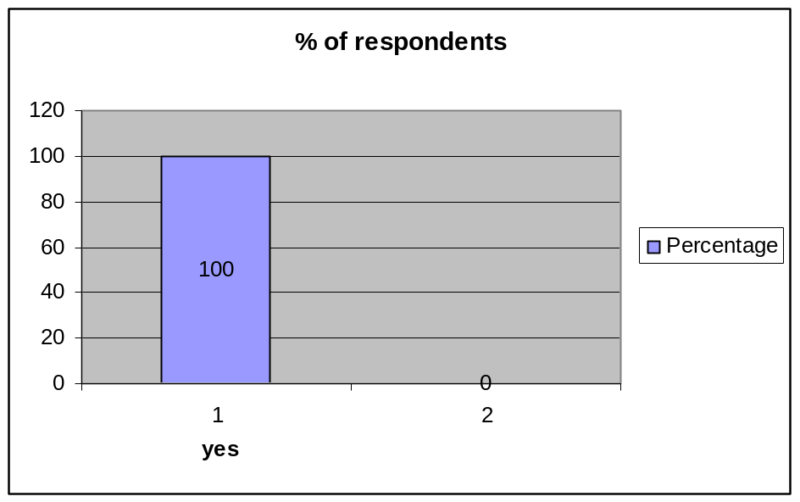
Figure 2: % of Performance
Interpretation:
To above question, almost 100% of the employees thought that the performance appraisal is needed in a company.

2. Performance appraisal rating is used to
(a) Identify areas of improvement
(b) Identifying quality for unit of work
(c) Set performance target
(d) All the above

s.no | Options | No. of Responses | Percentage
1 | Identify areas of improvement | 28 | 28
2 | Identify areas of training & development | 48 | 48
3 | Set performance target | 8 | 8
4 | All the above | 16 | 16
 | Total | 100 | 100
Table 7: % of Performance appraisal rating

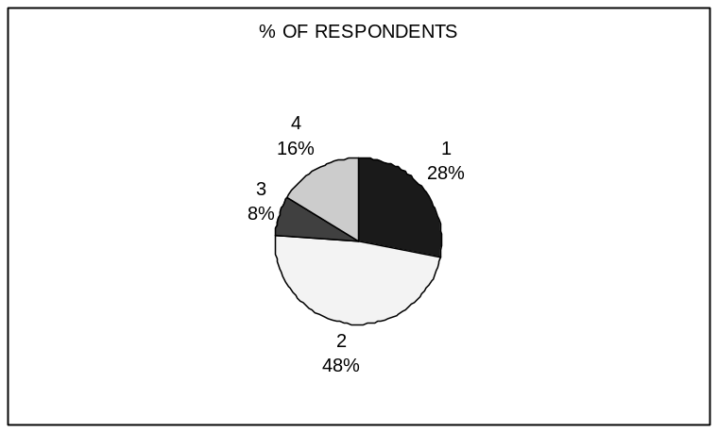
Figure 3: Performance appraisal rating
Interpretation:
About the useful of Performance appraisal system, 28% have said that appraisal system helped them to identify areas of improvement, to 48% it helped in identifying training & development needs, to 8% it helped in setting performance targets and to 16% it was helpful in all the above areas. By this we can say that P.A is helpful in one way or the other for the employees.

3. In your experience the outstanding Performance of an employee is due to:
(a) Actual Performance (b) Qualification
(c) Experience (d) All the above

s.no | Options | No. of Responses | Percentage
1 | Actual Performance | 28 | 28
2 | Qualification | 0 | 0
3 | Experience | 52 | 52
4 | All the above | 20 | 20
 | total | 100 | 100
Table 8: % of Outstanding Performance of an employee

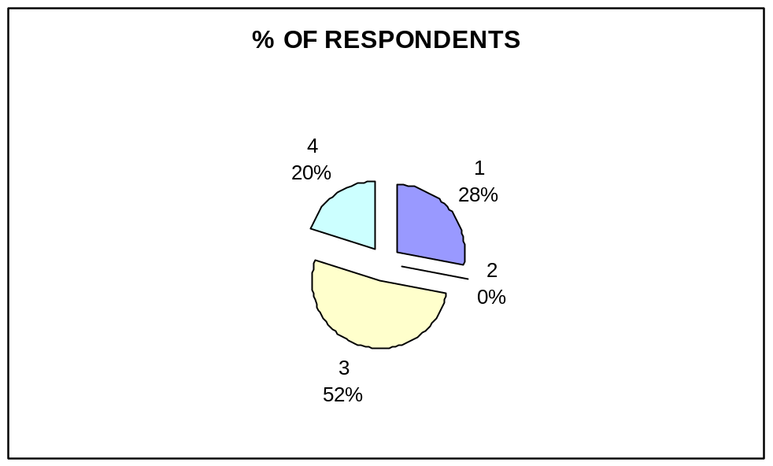
Figure 4: % of Outstanding Performance of an employee
Interpretation:
Above 28% of the employees responded that the outstanding Performance appraisal is due to Actual Performance, 52% of the employees is due to Experience and 20% of the employees is due to all the above.

4. Do you think that a good workman gets motivated with frequent Performance appraisal is conducted?
(a) YES (b) NO

s.no | Options | No. of Responses | Percentage
1 | YES | 88 | 88
2 | NO | 12 | 12
 | TOTAL | 100 | 100
Table 9: % of Frequent Performance appraisal

% of respondents
88% YES
12% NO
Figure 5: % of Frequent Performance appraisal
Interpretation:
A majority of 88% of the employees said that a good workman gets motivated with frequent Performance Appraisal and 12% of the employees are not satisfied with above.

5. What are the factors taken into consideration while appraising an individual?
(a) Interpersonal effectiveness (b) Team building skills
(c) Self motivate skills (d) leadership

s.no | Options | No. of Responses | Percentage
1 | Interpersonal effectiveness | 20 | 20
2 | Teambuilding skills | 24 | 24
3 | Self motivate skills | 44 | 44
4 | Leadership | 8 | 8
 | Total | 100 | 100
Table 10: % of appraising an individual

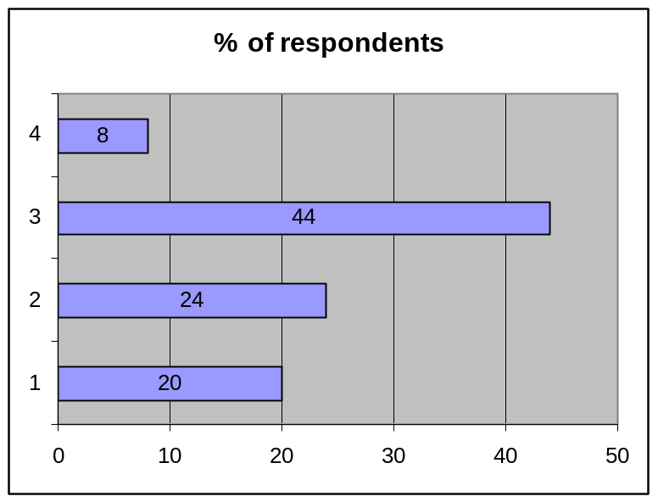
Figure 6: % of appraising an individual
Interpretation:
About 20% of employees considered interpersonal effectiveness while appraising an individual, 24% of employees considered Teambuilding skills, 22% of employees considered self motivate skills and 8% of employees considered Leadership. By this we can say that these are the factors taken into consideration while appraising an individual.

6. In your opinion an employee should be:
(a) Effective (b) Moderate (c) Both A & B

s.no | Options | No. of Responses | Percentage
1 | Effective | 80 | 80
2 | Moderate | 0 | 0
3 | Both A & B | 20 | 20
 | Total | 100 | 100
Table 11: % of Opinion an employee

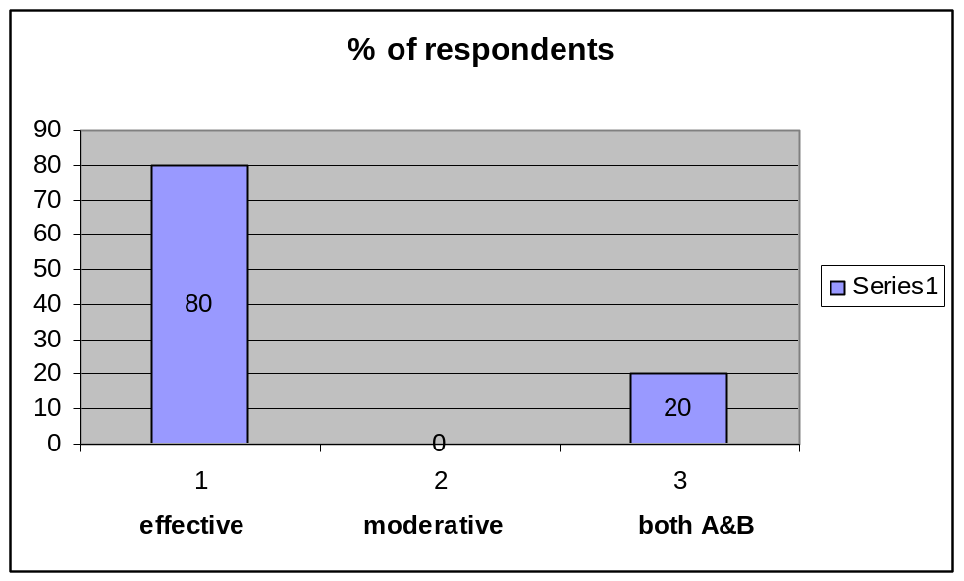
Figure 7: % of Opinion of an employee
Interpretation:
About 80% of the employee’s opinion is that the employee should be effective and rest 20% of the employee’s opinion is that the employee should be effective and moderate.

7. Which method you are using for evaluating Performance?
(a) 360 degree appraisal (b) MBO (c) Assessment centre
(d) BARS (e) Any other

s.no | Options | No. of Responses | Percentage
1 | 360 degree appraisal | 48 | 48
2 | Mgmt By Objects | 24 | 24
3 | Assessment centre | 8 | 8
4 | BARS | 12 | 12
5 | Any other | 8 | 8
 | Total | 100 | 100
Table 12: % of Evaluating Performance

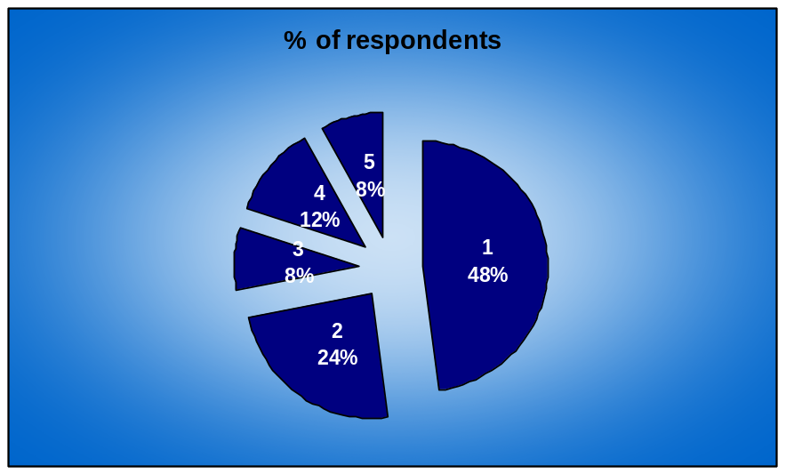
Figure 8: % of Evaluating Performance
Interpretation:
About 48% of the employees using 360 degree appraisal method for
evaluating Performance, 24% of the employees using Mgmt By Objects, 8% of the
employees using Assessment centre, 12% of the employees using BARS, 8% of the
employees using other method.

8. Is Appraisal process expensive and time consuming?
(a) YES (b) NO

s.no | Options | No. of Responses | Percentage
1 | YES | 64 | 64
2 | NO | 36 | 36
 | Total | 100 | 100
Table 13: % of Appraisal expensive and time consuming

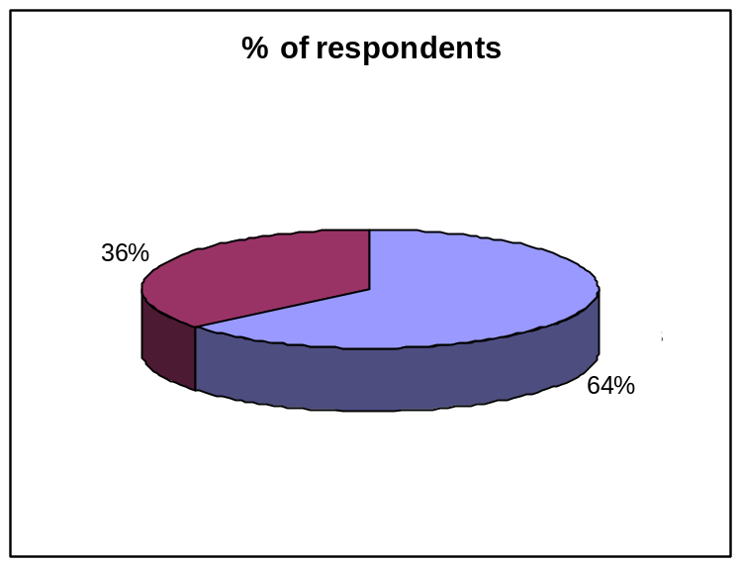
Figure 9: % of Appraisal expensive and time consuming
Interpretation:
About 64% of the respondents said that the performance appraisal is expensive and time consuming. And 36% of the respondents said that the Performance appraisal is not expensive and time consuming.

9. Do you agree with the assessment of your reviewing/reporting officers?
(a) Agree (b) Disagree

s.no | Options | No. of Responses | Percentage
1 | Agree | 92 | 92
2 | Disagree | 8 | 8
 | Total | 100 | 100
Table 14: % of assessment
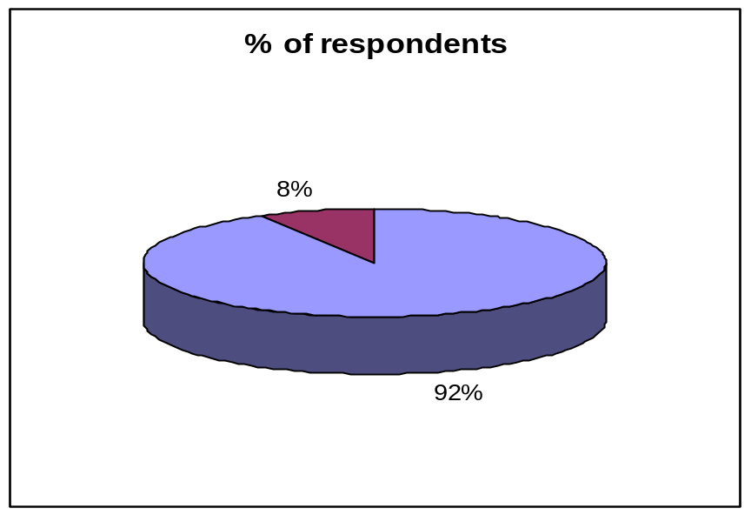
Figure 10: % of assessment
Interpretation:
Majority of 92% of the employees responded that reporting officer was good at grading the performance. Nearly 8% were disagreeing his duties as per the guidelines laid down.

10. Do you want any change in frequent between the appraisals?
(a) YES (b) NO

s.no | Options | No. of Responses | Percentage
1 | YES | 72 | 72
2 | NO | 28 | 28
 | Total | 100 | 100
Table 15: % of change in Appraisal

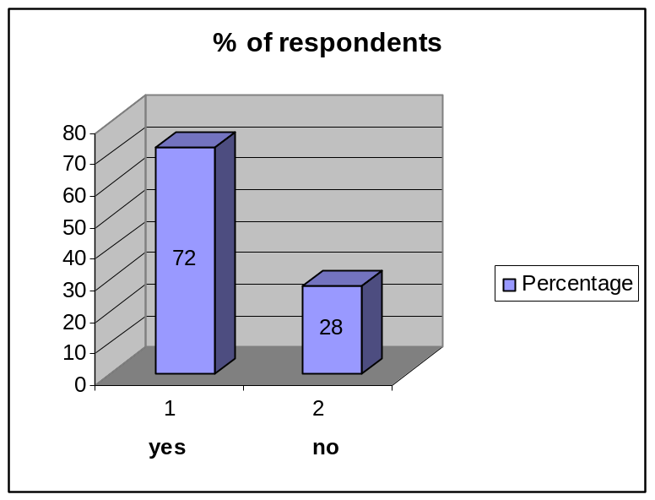
Figure 11: % of change in Appraisal

11. Have you been able to express all difficulties & problems which you have been facing
Regarding your job & achievement of your performance area?
(a) YES (b) NO

s.no | Options | No. of Responses | Percentage
1 | YES | 100 | 100
2 | NO | 0 | 0
 | Total | 100 | 100
Table 16: % of Job and Achievement

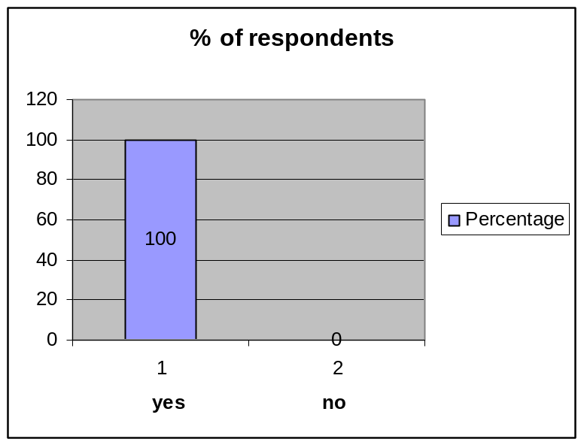
Figure 12: % of Job and Achievement

Interpretation:

About 100% of the employees are able to express all difficulties & problems which they have been facing regarding their job.

12. Frequency at which merit rating/Performance appraisal is conducted?
(a) 1year (b) 2years (c) half yearly (d) Quarterly

s.no | Options | No. of Responses | Percentage
1 | 1YEAR | 36 | 36
2 | 2YEARS | 0 | 0
3 | HALF YEARLY | 52 | 52
4 | QUATERTLY | 12 | 12
 | TOTAL | 100 | 100
Table 17: % of Merit Rating

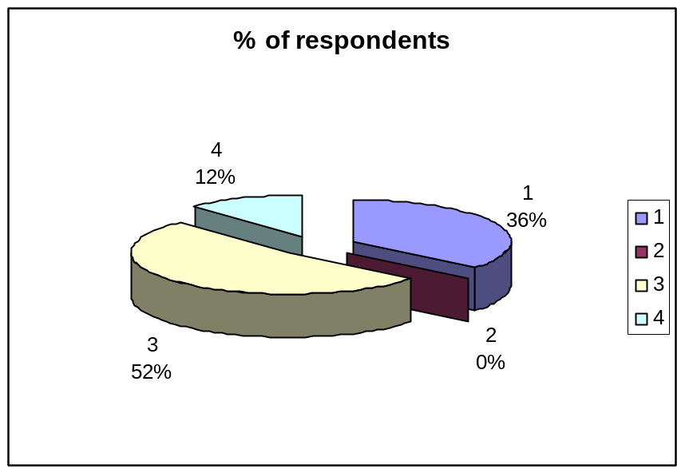
Figure 13: % of Merit Rating

Interpretation:
About 36% of the employees conducted merit rating/performance appraisal at the frequency 1year, 52% of the employees conducted at half yearly,12% of the employees conducted at quarterly.

13. Are you satisfied with present Performance appraisal system?
(a) YES (b) NO

s.no | Options | No. of Responses | Percentage
1 | YES | 64 | 64
2 | NO | 36 | 36
 | TOTAL | 100 | 100
Table 18: % Present Performance Appraisal

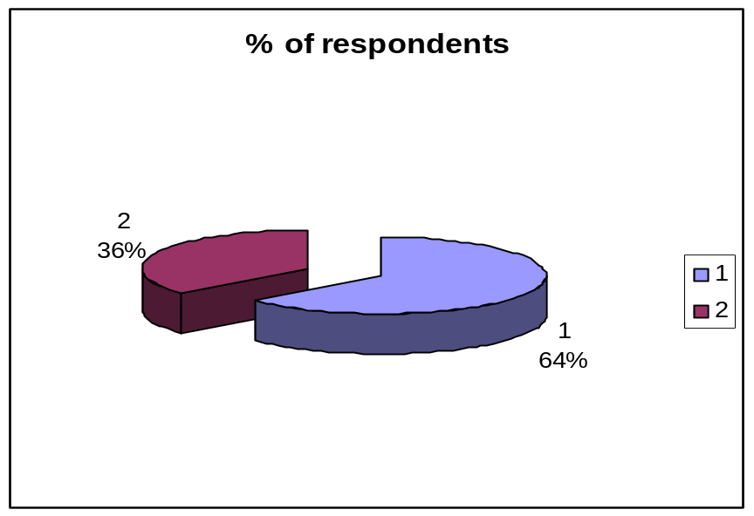
Figure 14: % Present Performance Appraisal

Interpretation:

About 64% of the employees were satisfied with present Performance appraisal system. Rest 36% of the employees was not satisfied with present system.

14. The appraisal is an opportunity for self-review & reflection?
(a) YES (b) NO

s.no | Options | No. of Responses | Percentage
1 | YES | 80 | 80
2 | NO | 20 | 20
 | TOTAL | 100 | 100
Table 19: % self-review

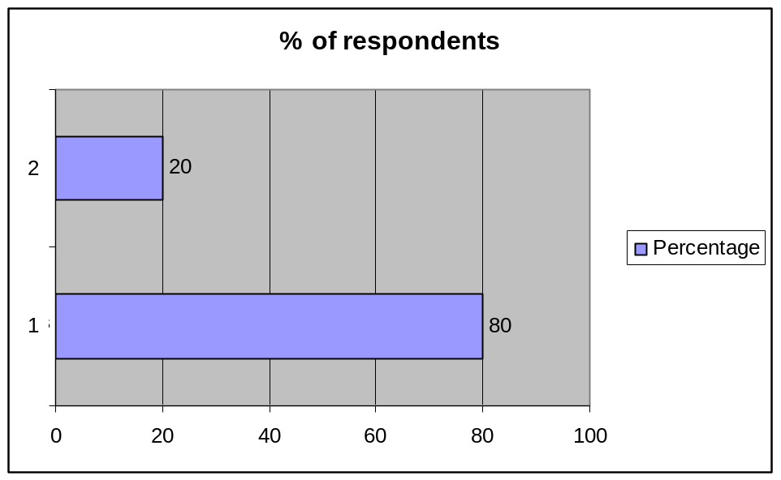
Figure 15: % self-review

Interpretation:
About 80% of the respondents have agreed that it’s an opportunity to review themselves. About 20% of them said that it does not help them in reviewing themselves.

15. Do you think the reward system is fair and adequate?
(a) YES (b) NO

s.no | Options | No. of Responses | Percentage
1 | YES | 72 | 72
2 | NO | 28 | 28
 | TOTAL | 100 | 100
Table 20: % reward system

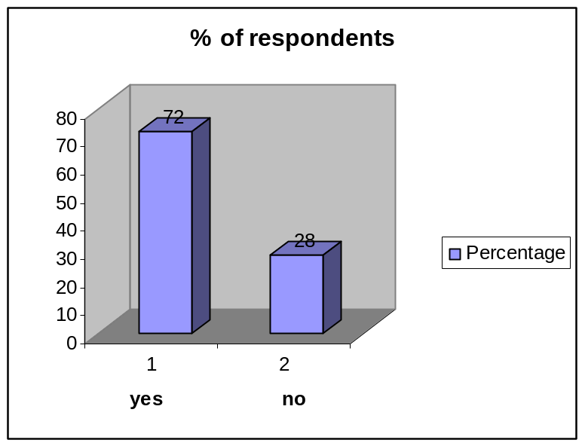
Figure 16: % reward system

Interpretation:

About 72% said that the reward system is fair and adequate and 28% responded that it is not fair.

5.1 FINDINGS
1. In the light of the above discussion the following findings are made.
- It is revealed that the executive are getting feedback on their performance though which they can review their performance. Sort on the problems and can overcome the difficulties.
- The management has a clear understanding about the problem that the workers are the best with moreover, they are eager to solve the problems of the workers as and when they arise.
- The management was giving requisite training to workers in the areas where they are weak.
- Workers awareness about the fact that the appraisal is one of the factors for promotion was cent percent.
- Performance appraisal system is considered as a means that aim at identifying the areas of improvement, identifying areas of training and development setting performance target for future.
- The management desire having cordial relations with the work to hold mutual discussions.
- The performance appraisal system it exists as it exists now is properly worked out and appropriately evolved. This revealed from the opinion given by the majority of the employees.

5.2 Conclusion
1. The rating instruments, which should strive for simplicity not complexity, are derived from job analysis.
2. Training is provided to all employees about the systems and to managers in its use.
3. The appraisal is grounded in accurate job descriptions and the actual ratings are based on observable performance.
4. Evaluations are completed under standardized conditions and are free of adverse impact.
5. Preliminary results are shared with the rate.
6. Some form of upper level review, including an appeal process, exists that prevents a single manager from controlling an employee's career.
7. Performance counseling and corrective guidance services exist.
While many systems may not compare favorably to such standards, recall that the crux of the appraisal problem is not system design. Instead, since evaluation is a matter of human judgment, the conundrum is how the plan and the information it generates is used.
As we peer into the century ahead, personnel appraisal will become either more or less complex. Should the long standing preference for person-centered evaluations persist, then organizational downsizing and workforce changes will likely complicate appraisals. The virtual workplace unbound by time and space is apt to exacerbate this situation.

5.3 RECOMMENDATIONS
Based on the findings of the study and personal discussions held with various executives and employees at HERITAGE FOODS INDIA Ltd's., Hyderabad possible suggestions and recommendations are given:
- It is recommended that employees should be immediately communicated.
- The result of the appraisal particularly when they are negative.
- It is recommended that the supervisor should try to analyze the strengths and weaknesses of an employee and advise him on correcting the weakness.
- It is commended to counsel the employees appropriately regarding their strength and weaknesses and assist in developing them to realize their full potential in line with the company’s goals.
- The top management is very much committed in implementing the performance appraisal system as it is. The performance appraisal system is consider as an essential tool for bridging gap between the top management and the executives it thus helps them to develop cordial relations and mutual understanding.
- It is recommended that the employees should be communicated information about his performance, again his acceptance of it and draw up a plan for future improvement, if necessary.
- It is recommended that the rater must be thoroughly well versed in the philosophy and of the rating system. Factor sales must be thoroughly defined, analyzed and discussed.
To conclude, it is imperative to immunize of the problems or hindrances to strengthen the system.

QUESTIONNAIRE
PERSONAL DATA

NAME :
DESIGNATION :
DEPARTMENT :
EXPERIENCE :

- Do you think Performance appraisal is needed in a Company?
(a) YES (b) NO

- Performance appraisal rating is used to
  - Identify areas of improvement
  - Identify areas of training and development
  - Set performance target
  - All the above
3. In your experience the outstanding Performance of an employee is due to:
(a) Actual Performance (b) Qualification
(c) Experience (d) All the above

4. Do you think that a good workmen gets motivated with frequent Performance appraisal is conducted?
(a) YES (b) NO

5. What are the factors taken into consideration while appraising an individual?
(a) Interpersonal effectiveness (b) Teambuilding skills
(c) Self motivate skills (d) Leadership

6. In your opinion an employee should be:
(a) Effective (b) Ineffective (c) Both A & B

7. Which method you are using for evaluating Performance?
(a) 360 degree appraisal (b) MBO (c) Assessment center
(d) BARS (e) Any other

8. Is it expensive and time consuming?
(a) YES (b) NO

9. Do you agree with the assessment of your reviewing/reporting officers?
(a) Agree (b) Disagree

10. Do you want any change frequency between the appraisals?
(a) YES (b) NO

11. Have you been able to express all difficulties & problems which you have been
Facing regarding your job & achievement of your performance area ?
(a) YES (b) NO

12. Frequency at which Performance appraisal is conducted
(a) 1year (b) 2years (c) half yearly (d) Quarterly

13. Are you satisfied with present Performance appraisal system?
(a) YES (b) NO

14. The appraisal is an opportunity for self review & reflection
(a) YES (b) NO

15. Do you think the reward system is fair and adequate?
(a) YES (b) NO
6. BIBLIOGRAPHY

- Edward E. Lawler Iii; John W. Boudreau, Human resource management, Stanford Business Books, 2009
- Ronald J. Burke; Cary L. Cooper, Challenges and new Direction on Human Resource Management, Routledge, 2005
- John H. McConnell, HR Policies and Procedures, AMACOM, 2005
- Nehles, Anna C.; van Riemsdijk, Maarten; Kok, Irene; Looise, Jan Kees, Implementing Human Resource Management, Management Revue, Vol. 17, No. 3, July 1, 2006.

HERITAGE FOODS INDIA Ltd's PERSONNEL MANUAL 2014-2015 Websites:
- www.hrindia.com
- www.heritage.com
- www.retailindia.com
- www.hrcouncil.org

